Alexander Cannell

1/23/13

Professer Robertson

CSIS 4700

1. Provide the packet numbers for the drive mapping to the class share.

From 249 to 734, Ethan tried to connect to the share several times.

Time Stamp: Jan 23, 2013 14:12:48.9100210000 Mountain standard

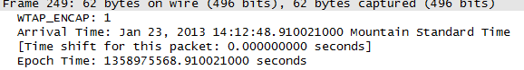

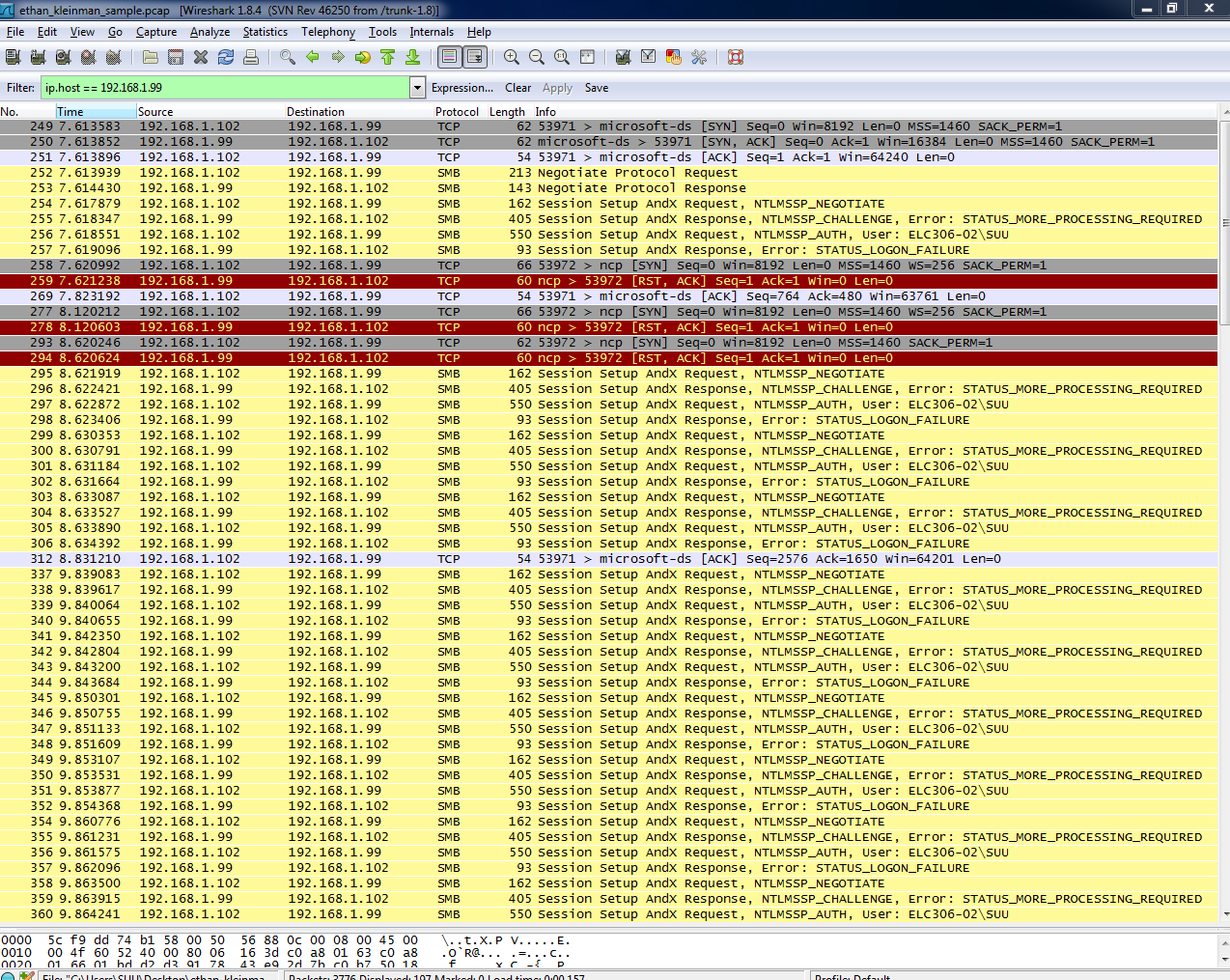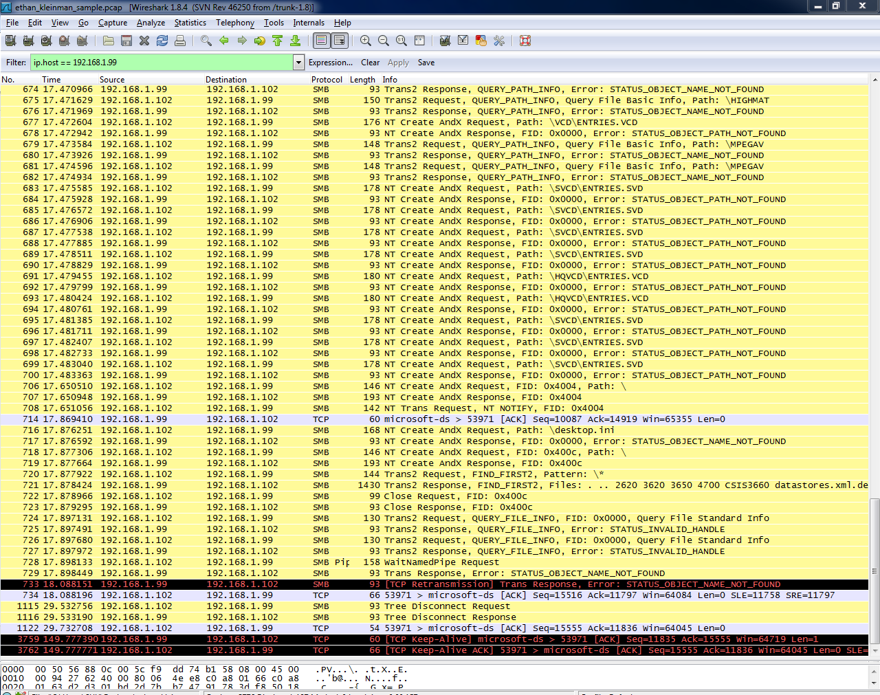

1. When did the User go to [www.google.com](http://www.google.com)? (Time, Date, Packet #)

Time Stamp: Jan 23, 2013 14:13:12.721658000 Mountain Standard Time

Packet #: 1176



Ethan was using chrome:



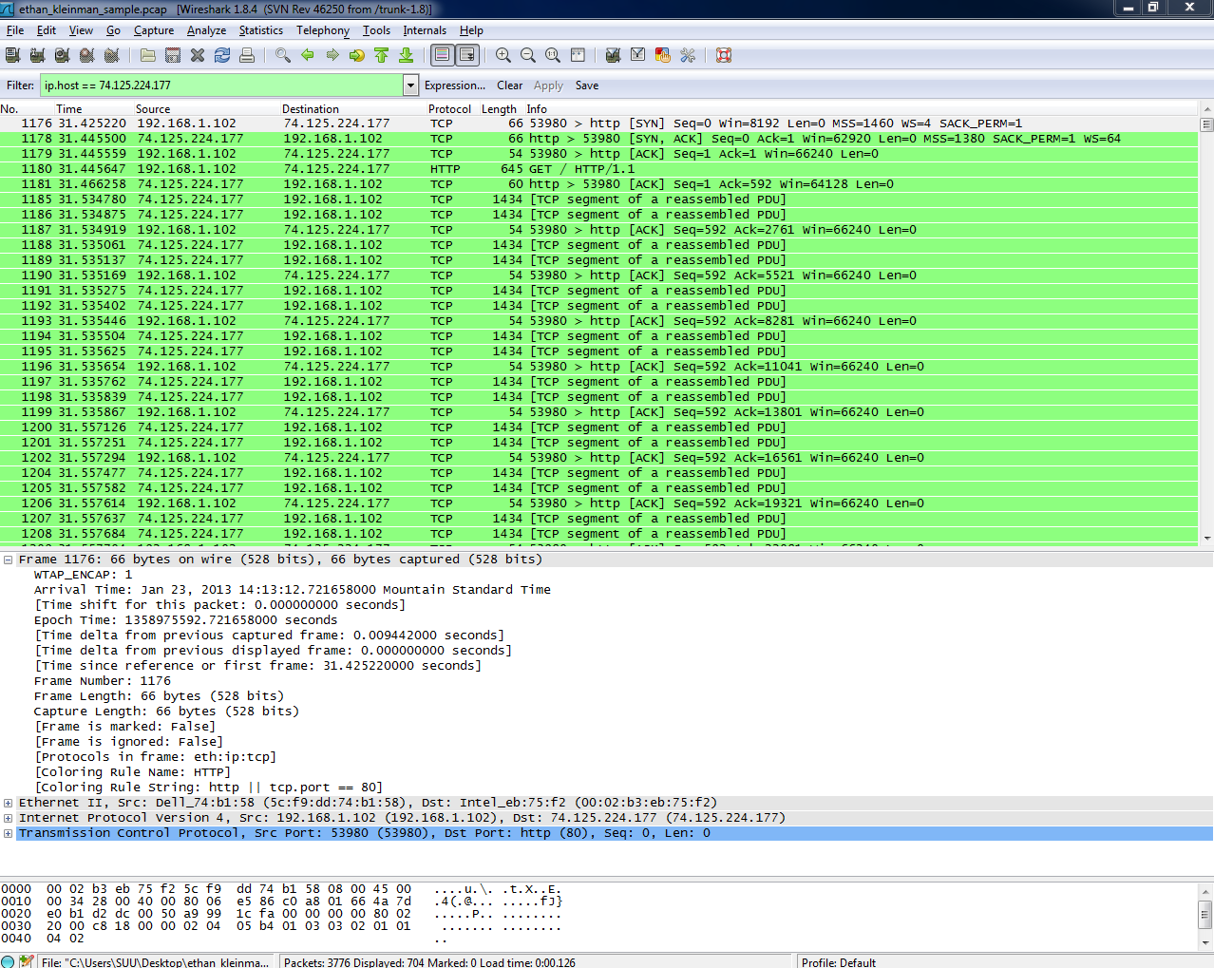

1. Provide the packet numbers, and date and time for the searches performed by the user:
2. Internet Forensics:

Time Stamp: Jan 23, 2013 14:13:17.84209400 Mountain Standard Time

Packet Number: 1752 to 2165

What I found interesting is that google does the current search and it shows up with every letter you typed in with a new search or a new request from google.

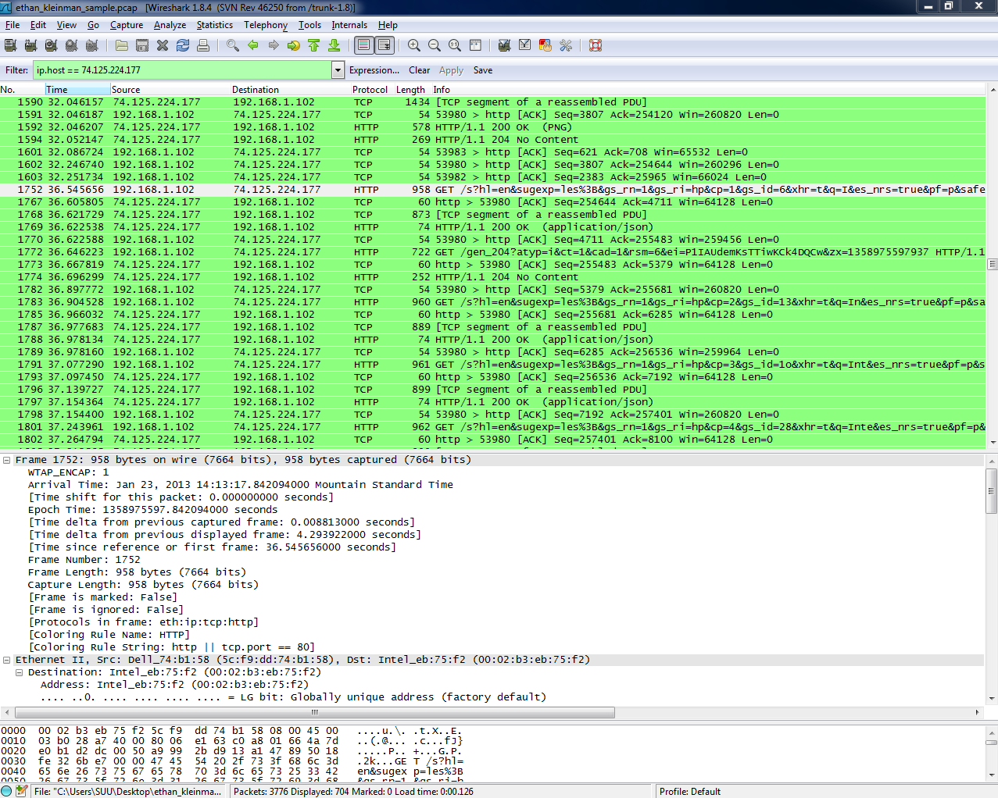

1. Cyber Security:

Time Stamp: Jan 23, 2013 14:13:30.72889900 Mountain Standard Time

Packet Number: 2322 to 2503

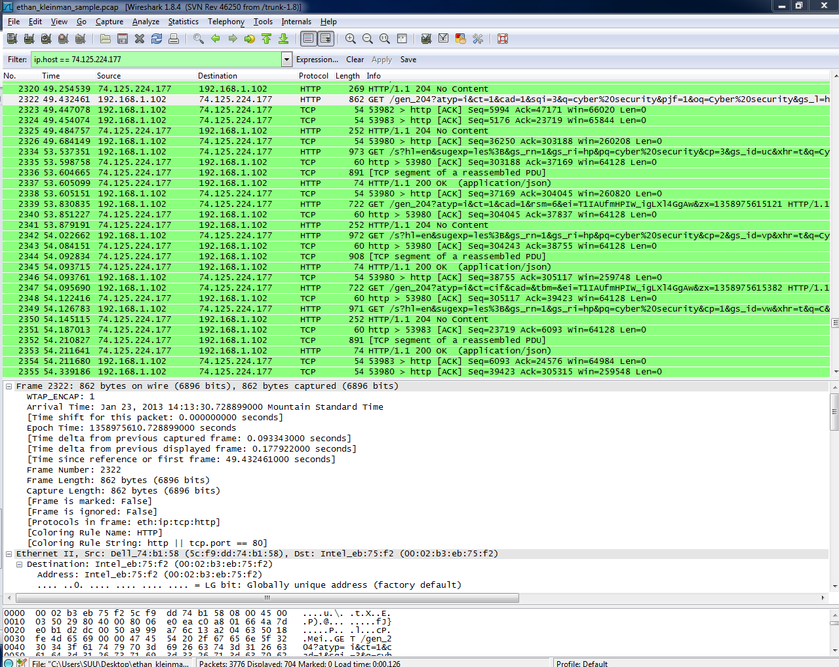

1. One other of your choosing (What was searched for?)

Ethan searched for lighting



Packet Number: 2513

Time Stamp: Jan 23, 2013 14:13:59.260266000 Mountain Standard Time

1. What were some of the user’s sites they surfed to?

Stackoverflow.com

Facebook.com

HomePage: suu.edu